

Web Player

Test Report

Test Session Summary

|  |  |
| --- | --- |
| Start: Mon Apr 13 07:49:20 2020 End: Mon Apr 13 07:50:38 2020 Duration: 0:01:18.098000  broken: 0 (0.00%) failed: 0 (0.00%) skipped: 0 (0.00%) passed: 9 (100.00%) |  |

Test Results

# Albums cards - passed

Testing Albums cards

## Test Setup

[Fixture] setup

## Test Body

[Attachment] SUCCESS: Albums cards are functional

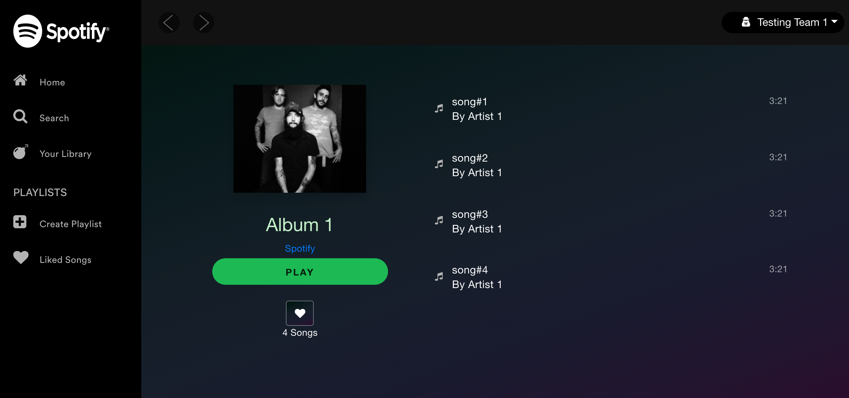

## Test Teardown

[Fixture] setup::0

# Artist cards button - passed

Testing Artists cards Button

## Test Setup

[Fixture] setup

## Test Body

[Attachment] ERROR: Playlist name is not the same as the card name. Card name = Artist 1  
Artist, Playlist name = Artist 1

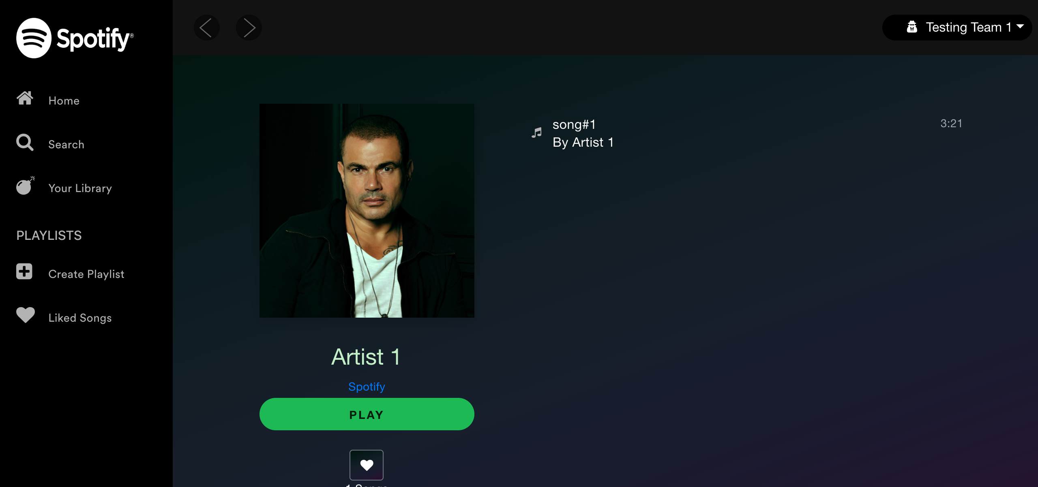

[Attachment] SUCCESS: Artists cards are functional



## Test Teardown

[Fixture] setup::0

# Liked Songs Button - passed

Testing Liked Songs Button

## Test Setup

[Fixture] setup

## Test Body

[Attachment] SUCCESS: Liked Songs button is functional

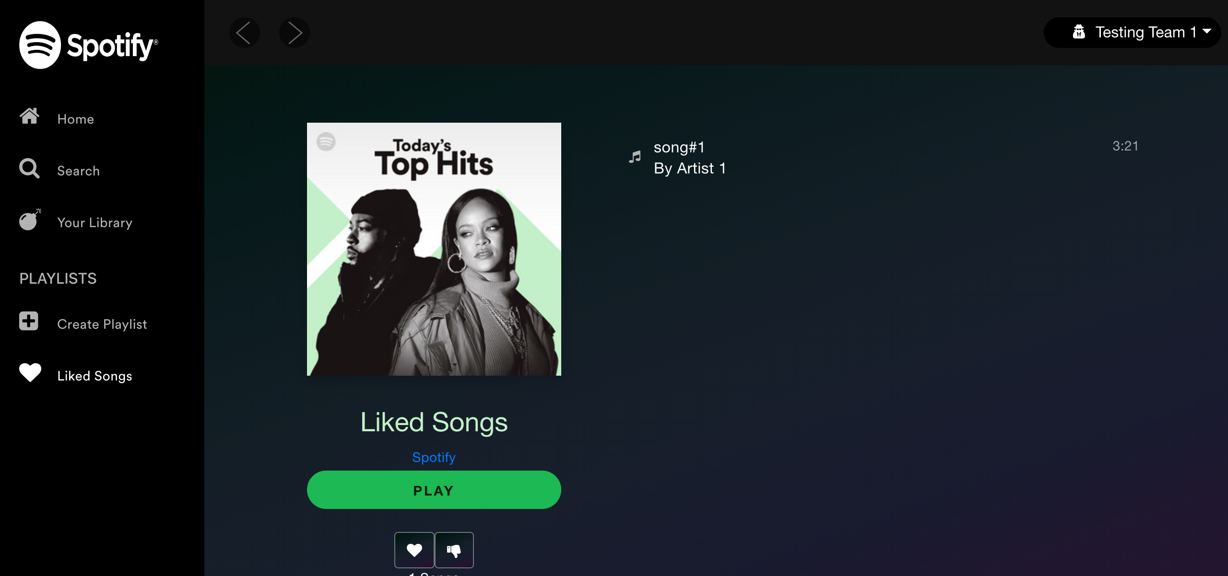

## Test Teardown

[Fixture] setup::0

# Logout button - passed

Testing Logout button

## Test Setup

[Fixture] setup

## Test Body

[Attachment] SUCCESS: Sign out button is functional

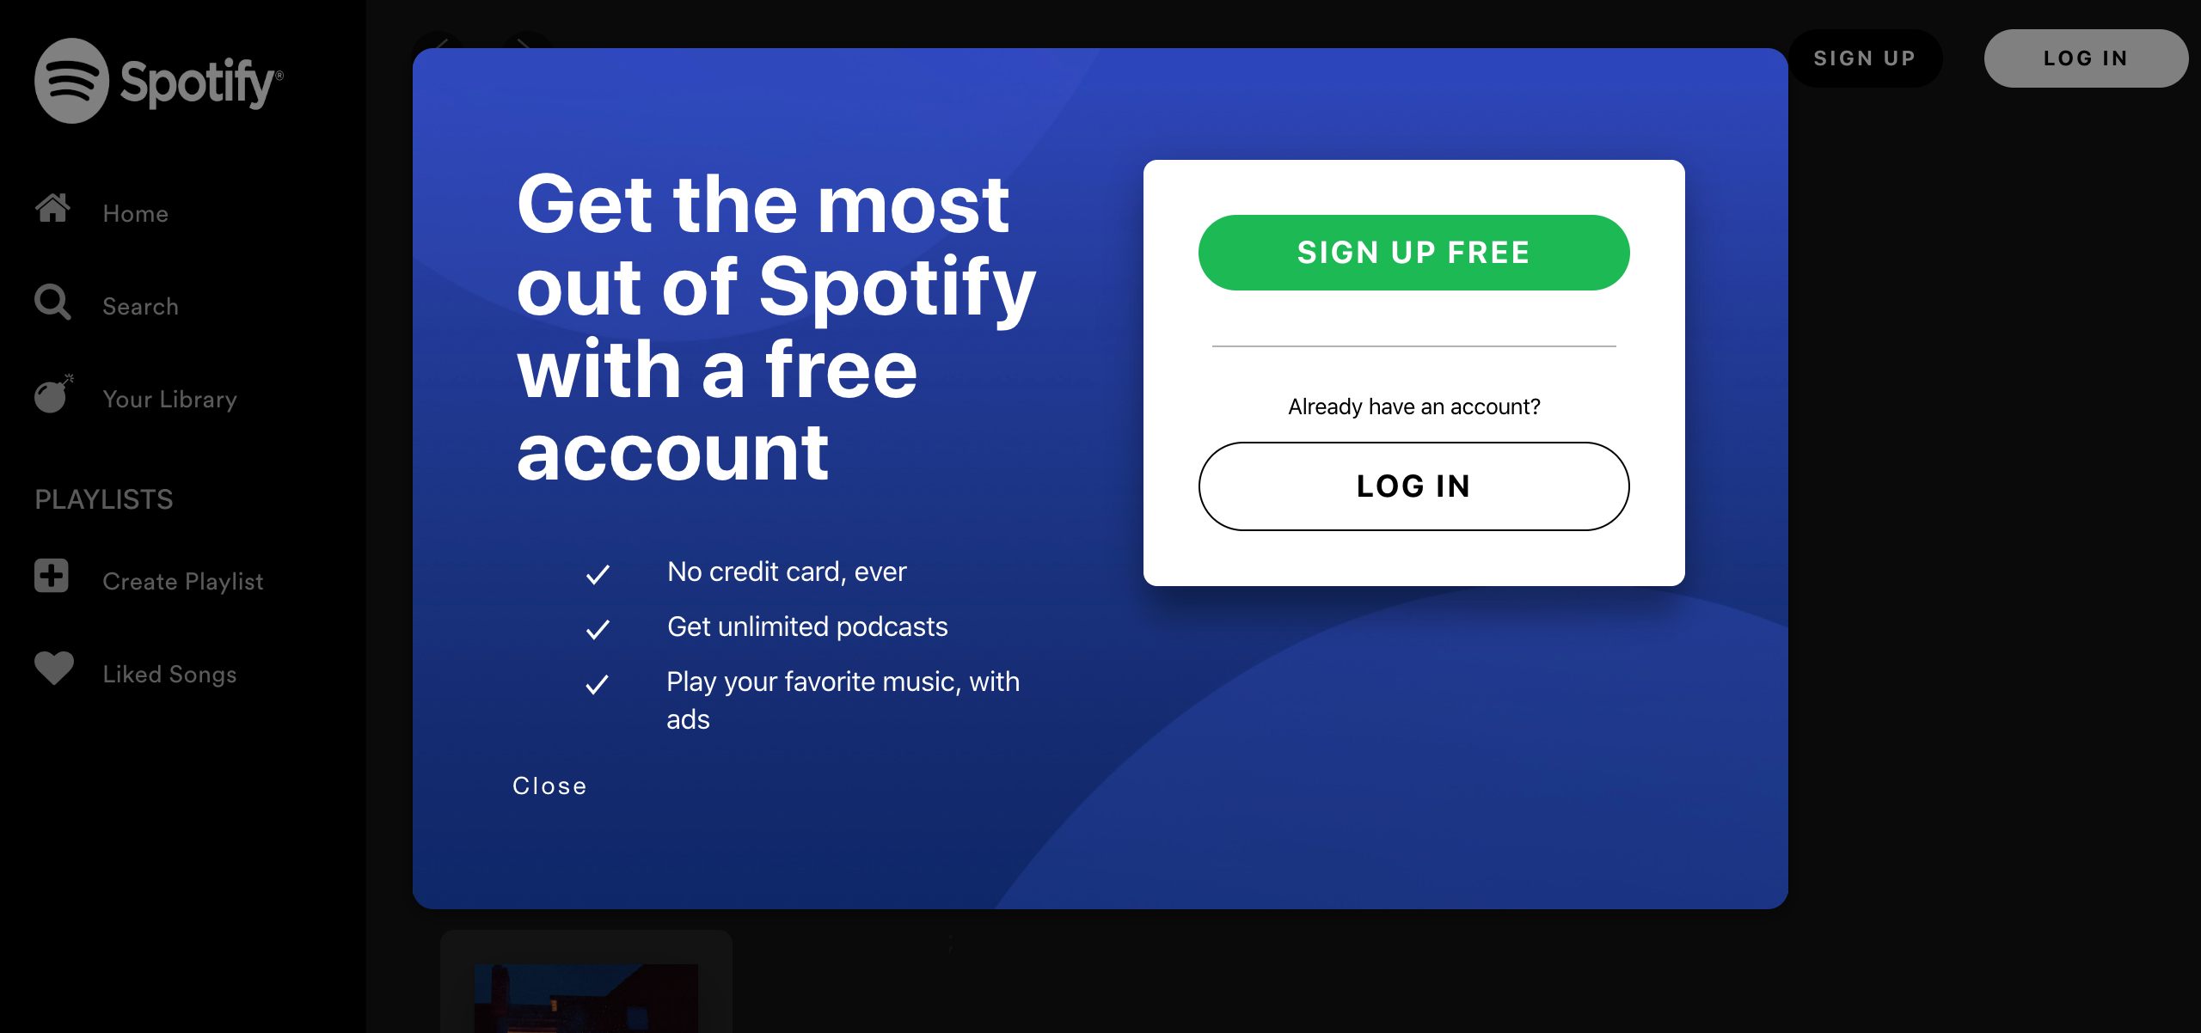

## Test Teardown

[Fixture] setup::0

# Playlists cards - passed

Testing Playlists cards

## Test Setup

[Fixture] setup

## Test Body

[Attachment] ERROR: Playlist name is not the same as the card name. Card name = Playlist 3  
Playlist, Playlist name = Playlist 3

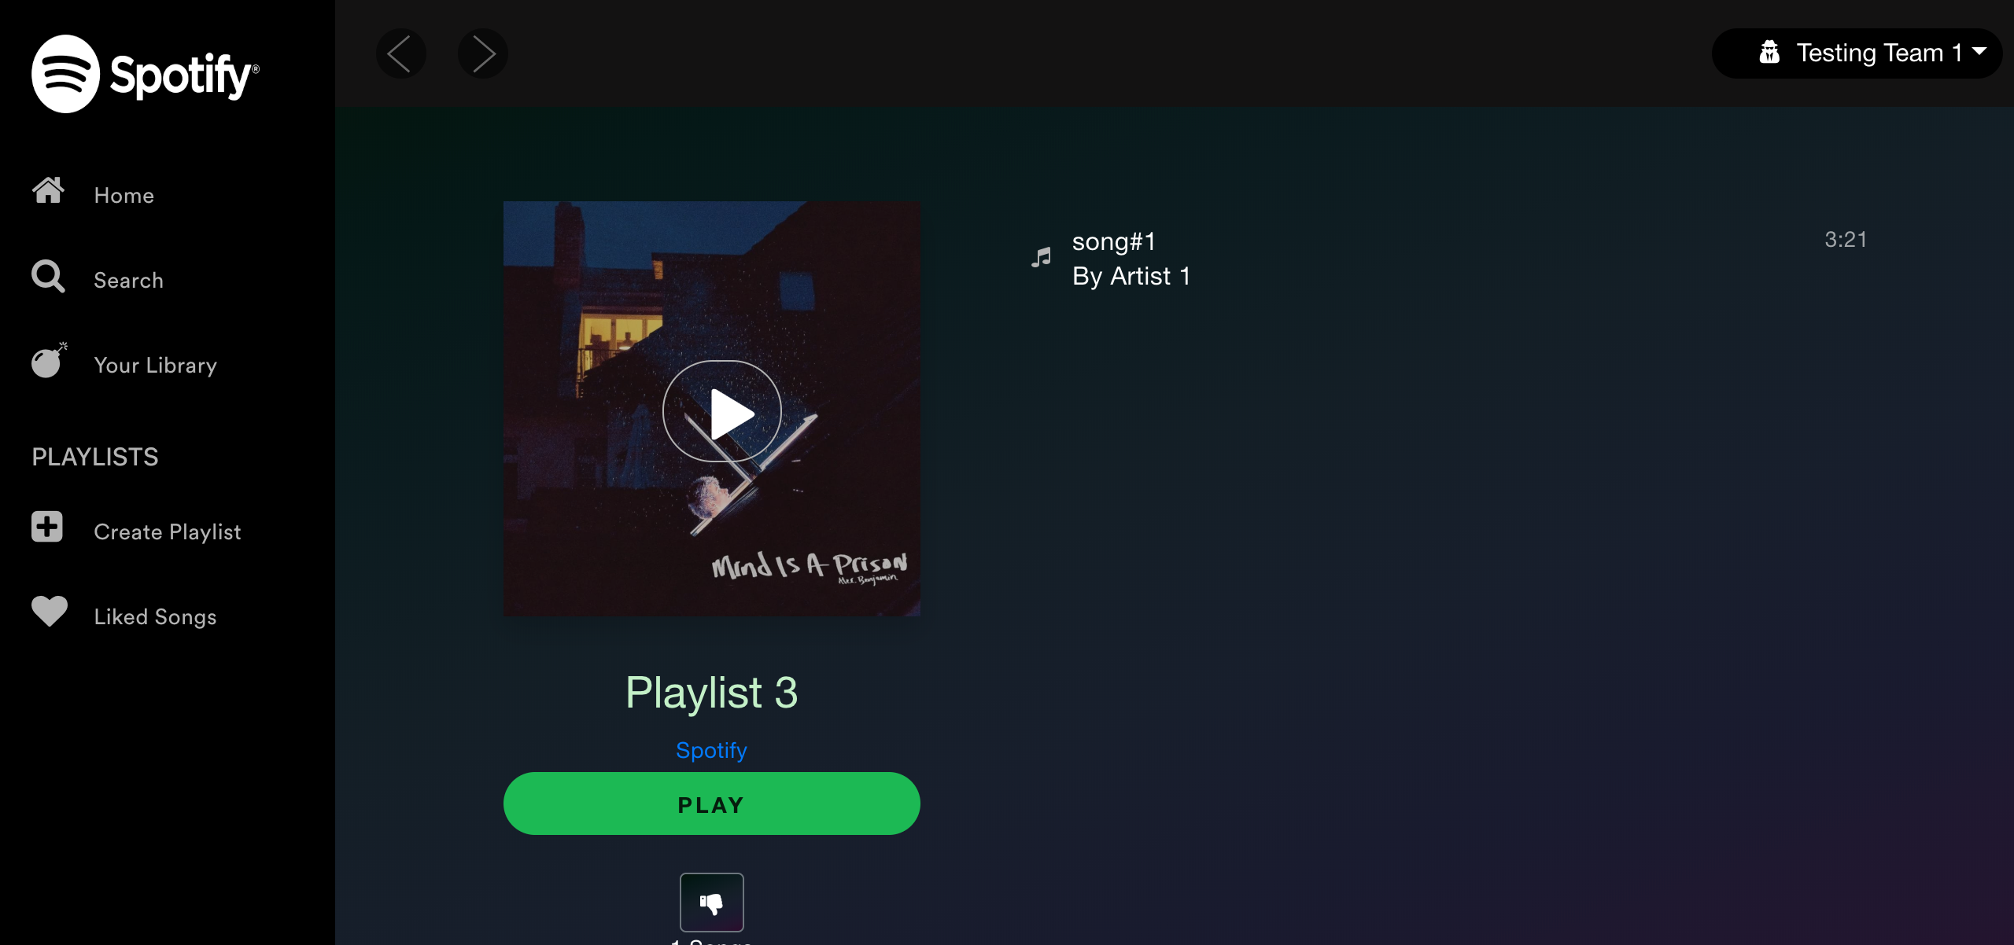

[Attachment] SUCCESS: Playlist cards are functional



## Test Teardown

[Fixture] setup::0

# Refresh Page - passed

Testing Refresh and make sure that elements are visible

## Test Setup

[Fixture] setup

## Test Body

[Attachment] SUCCESS: Elements are still visible after refresh

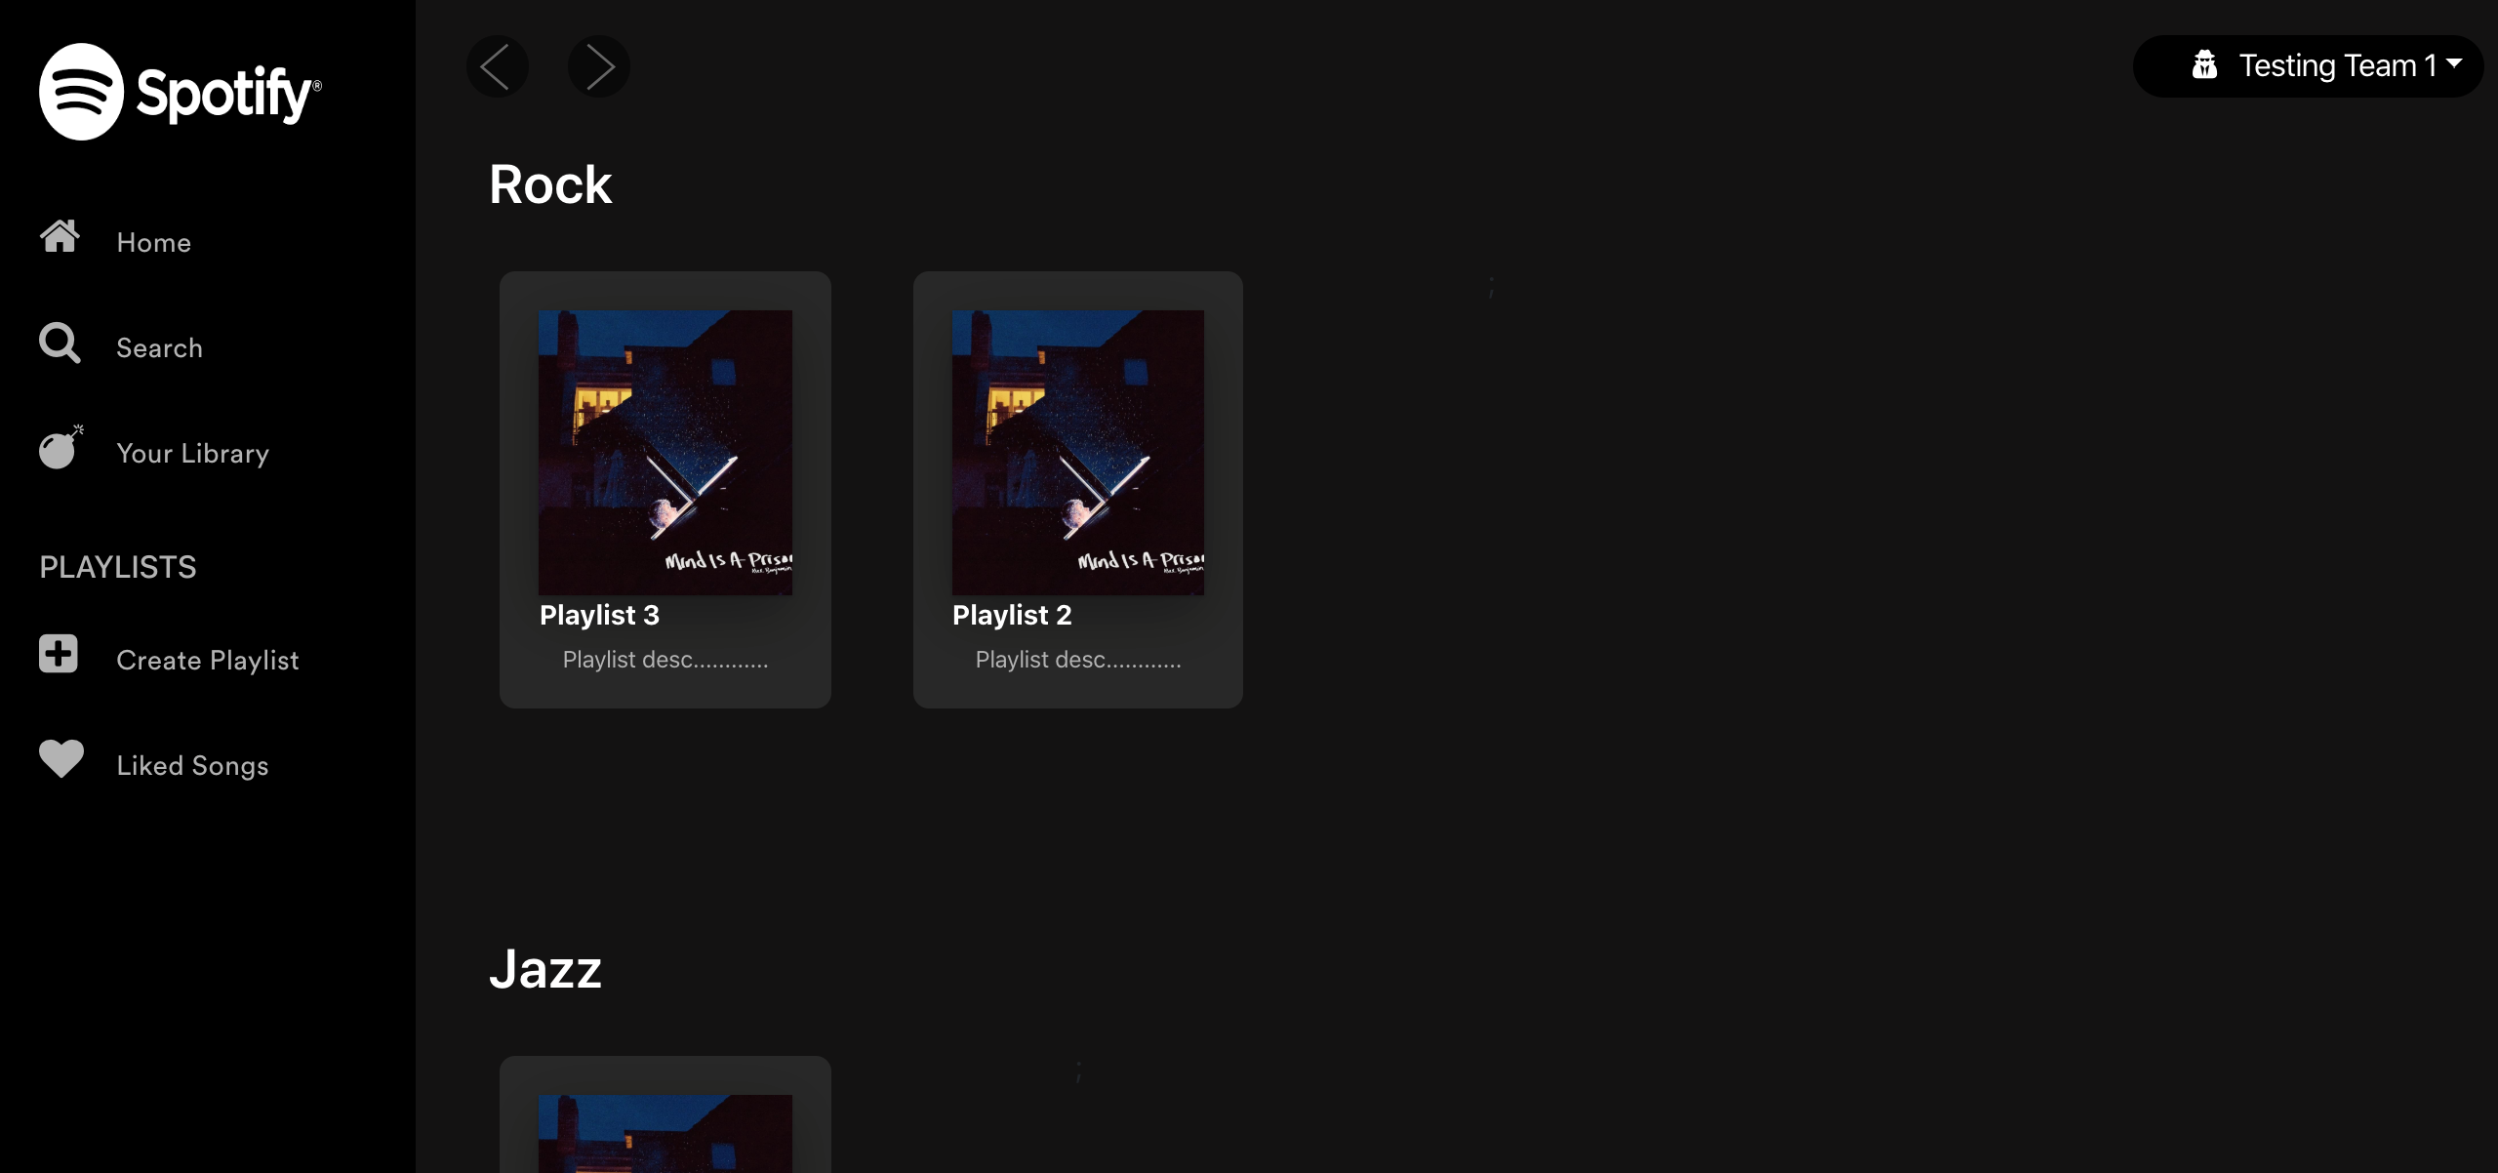

## Test Teardown

[Fixture] setup::0

# Testing Login button - passed

Testing Login button

## Test Setup

[Fixture] setup_final

## Test Body

[Attachment] SUCCESS: Login button is functional

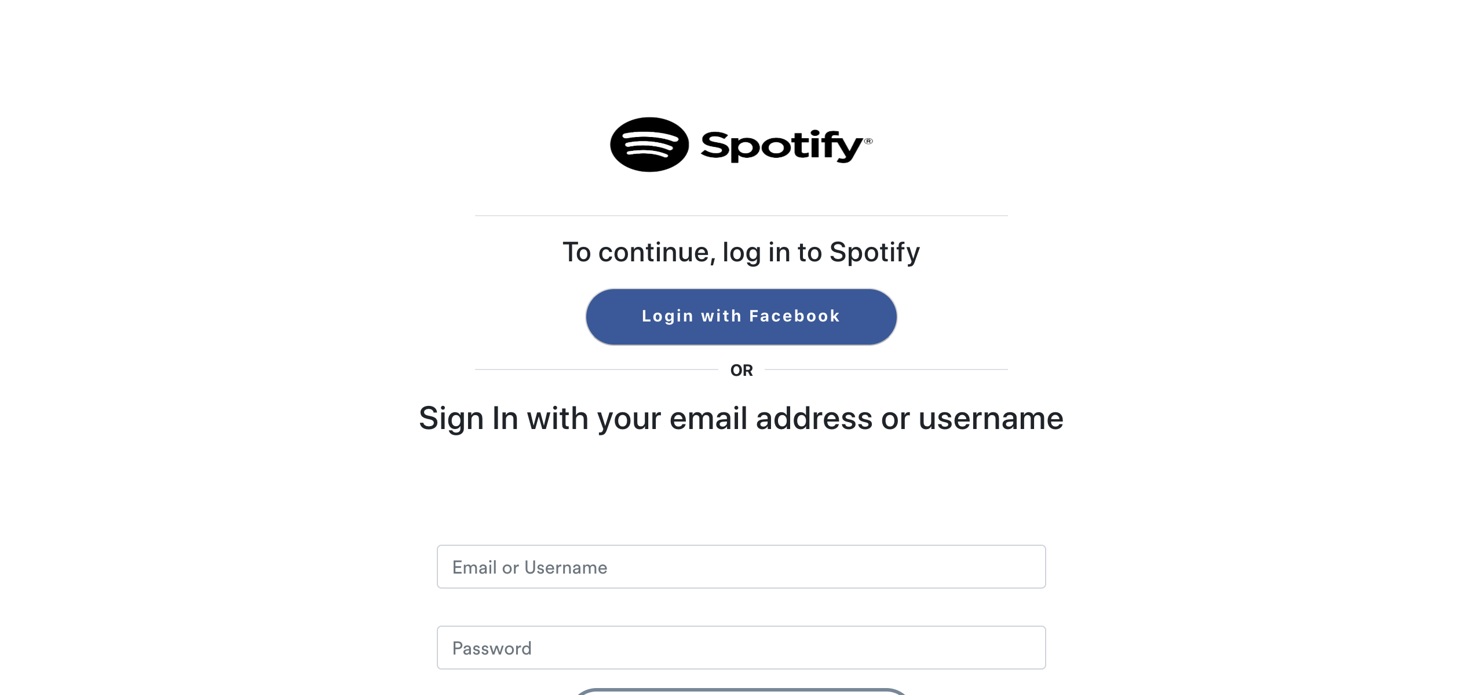

## Test Teardown

[Fixture] setup_final::0

# Testing Sign up button - passed

Testing Sign up button

## Test Setup

[Fixture] setup

## Test Body

[Attachment] SUCCESS: Sign up button is functional

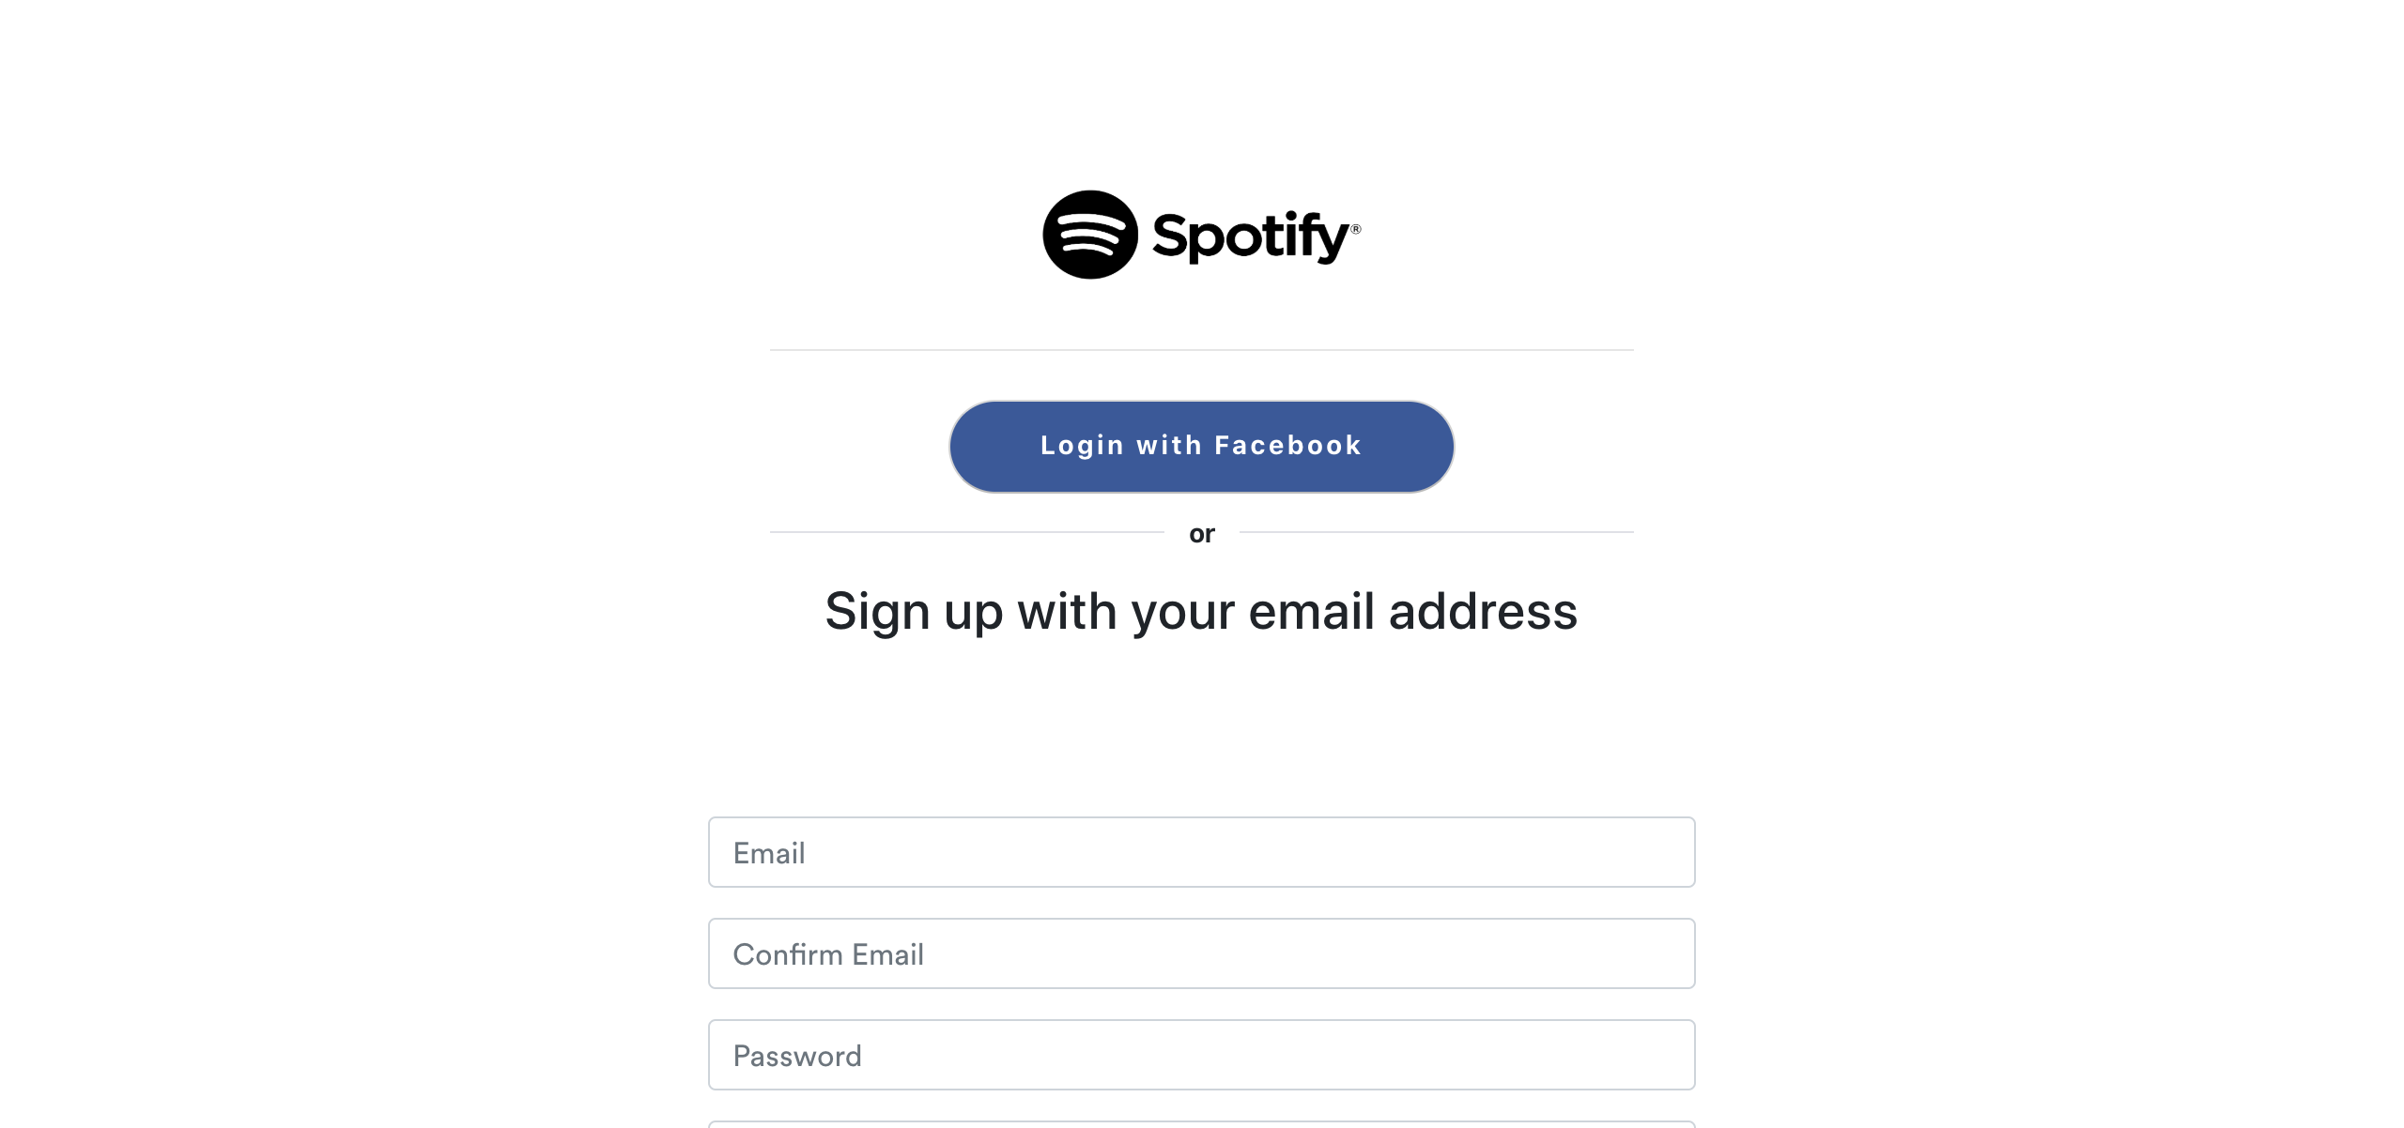

## Test Teardown

[Fixture] setup::0

# Your Library Button - passed

Testing Your Library Button

## Test Setup

[Fixture] setup_initial

## Test Body

[Attachment] SUCCESS: Your Library button is functional

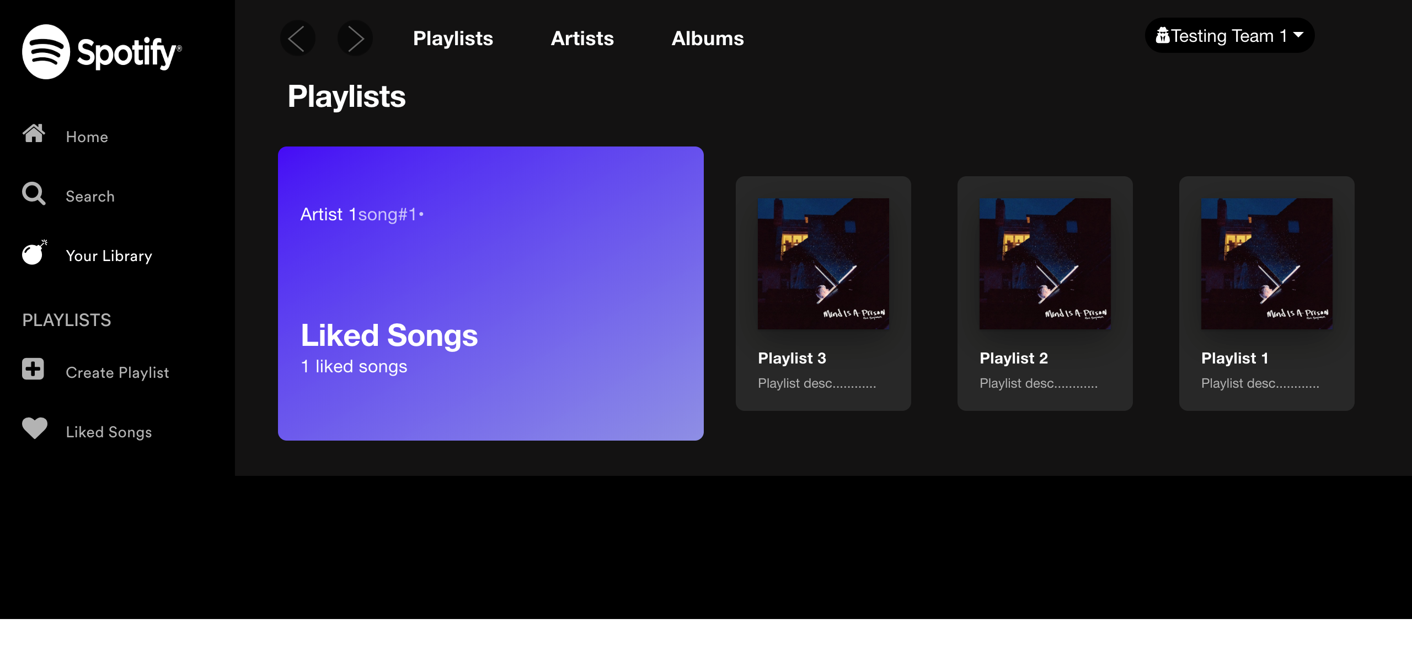

[Attachment] stdout

## Test Teardown

[Fixture] setup_initial::0